**CURRICULUM VITAE**

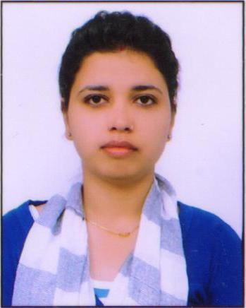**NAMITA**

H.No:749, Vijay Nagar

Konsiwas road, Rewari

Dist. Rewari (HR.)-123401

+919711545975/8901018166

[namitayadav1989@gmail.com](mailto:namitayadav1989@gmail.com)

**OBJECTIVE:**

To utilize my skills and abilities in the organisations that offer professional growth while being innovative, resourceful and flexible.

**SUMMARY:**

* Internship at Speedomax Ltd. And Automax (A unit of Omax autos Ltd.)
* Completed MBA with majors Marketing and HR
* Completed BBA from MDU, Rohtak
* Excellent communication skills
* Well versed with MS Office

**EDUCATIONAL QUALIFICATION:**

* Completed MBA (Marketing & HR) from Institute Of Management Studies and Research, MDU, Rohtak (2014)
* BBA from Institute Of Management Studies and Research, MDU, Rohtak (2012)

**INTERNSHIP:**

1. Speedomax (a unit of Omax Autos Ltd.), June 2011-August 2011

**Project**: Induction Training of Contractual Workers in Speedomax

**Summary:** The induction training survey help the company to identify workers queries and concerns in turn improvements were made and stronger teams were formed.

1. Automax (a unit of Omax Autos Ltd.) , June 2013- August 2013

**Project:** Social Security and Labour Welfare

**Summary:** The study was conducted to know how labour welfare and social security system of the organisation motivates their employees and suggestions were given to make it more effective and efficient so that the employees are satisfied.

**PROJECTS UNDERTAKEN:**

1. Completed project in BBA (6TH Semester)

**Title:** Training and Development of Employees

**Summary:** Analysed various aspects of employee training and development, nature and importance of training and development, training need for employees, training survey.

2. Completed project in MBA (4TH Semester)

**Title:** Impact of Advertisements on the Brand preference towards Snacks

**Summary:** Analyzed the consumer perception regarding the most effective media for advertisements and the impact of the celebrity endorsement on the consumer buying preference towards a particular brand.

**WORK EXPERIENCE:**

* **Worked with Indusind Bank,** Manesar ,as an Associate sales Officer, since 1st Dec. 2014 to 2nd Jan. 2016

### KEY ACHIEVEMENTS:

- Win Trophy of Excellence in Health Insurancefrom Zonal Head

- Win Trophy & Certificate from Regional Head for Highest CASA value and numbers in Month of March 2015.

* Certificate of Excellence in Acquisition value
* Trophy of Excellence in Acquisition value
* Certificate of Excellence in Life Insurance
* Trophy of Excellence in Health Insurance
* Cross-selling of all retail banking and Third party products

**EXTRA CURRICULUR ACTIVITIES:**

* Member of prefectorial team at school level
* Participated in social science exhibition at zonal level
* Participated in various dance competitions at School level
* Placement cell coordinator in college

**HOBBIES:**

Listen to music, cooking, painting, going out with friends, interacting with people

**PERSONAL DETAILS:**

Date of Birth : September 17, 1989

Husbands Name : Mr. Harish kumar yadav

Sex : Female

Marital Status : Married

Nationality : Indian

Languages : English, Hindi

NAMITA YADAV